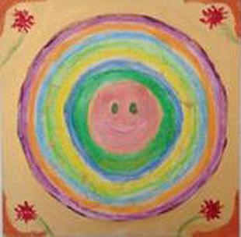
Some ideas & reflective cues that maybe helpful for creating a Mandala
Choice of making a ‘ Me Here Now’ Mandala and / or your own personal ‘Flourishing Mandala’

- Prepare the Materials you would like to use, choosing colours, textures you are drawn to
- Calm the mind – use a creative affirmation
- Think of a statement to assist you eg “No-one is going to judge my creative expression. I am doing this for myself”
- Close your eyes, breathe and go inside…
- See what’s there
- What colours, images, textures emerge?
- What is the energy like, how is it today?
- If you were a colour what would it be?
- Draw the circle, let the drawing emerge, Be spontaneous. Don’t think about what you want to paint or draw, just put the crayon or pencil on the paper and move it – something will emerge and release the flow in you
- Fill the circle with the image
- Try to give your Mandala a name, sign and date it.
- Mandala is a mirror for looking inside, reflects ‘me’ in this moment…
- Spend 5 mins quietly journaling around it…
- What did you notice?
- As this Mandala has come from you, it is part of you… “There is nobody to please, nothing to prove. Your own originality and creativity is worthy of celebrating”

