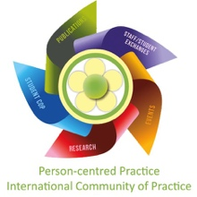

Account of Person-centred Moments (Method 1)

Please use this sheet to record an overview or summary of any person-centred moments you see in your workplace.
Workplace: Your name: Date:
Description of the moment:

Embedding the Moment in the Person-centred Framework: (Circle or tick ONE of the following outcomes you feel the moment was most contributing to)
Good care experience:
Involvement with care:
Feelings of well-being:
Existence of a healthful culture:
Please offer verbal feedback to the people involved in the moment and note their response here:

